

Artificial Intelligence
( Course Code: CSC262 )

Name : Muhammad Abdullah
Roll No # FA24-BSE-042
Instructor Name : Sir Waqas

Lab # 2

Lab Task 1-2:

# Lab Task 1
list1 = list(map(int, input("Enter first list (space-separated): ").split()))
list2 = list(map(int, input("Enter second list (space-separated): ").split()))

merged_list = sorted(list1 + list2)
print("Merged & Sorted List:", merged_list)

# Lab Task 2

print("Smallest:", min(merged_list))
print("Largest:", max(merged_list))

Output:

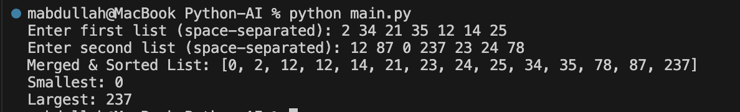

Lab Task 3:

# # Lab Task 3
from math import sin, cos, pi

h = 0.001 # step size
x = -pi

while x <= pi:
derivative = (sin(x + h) - sin(x)) / h # numerical derivative
print(f"x={x:.3f}, Approx={derivative:.6f}, cos(x)={cos(x):.6f}")
x += 0.001

Output:

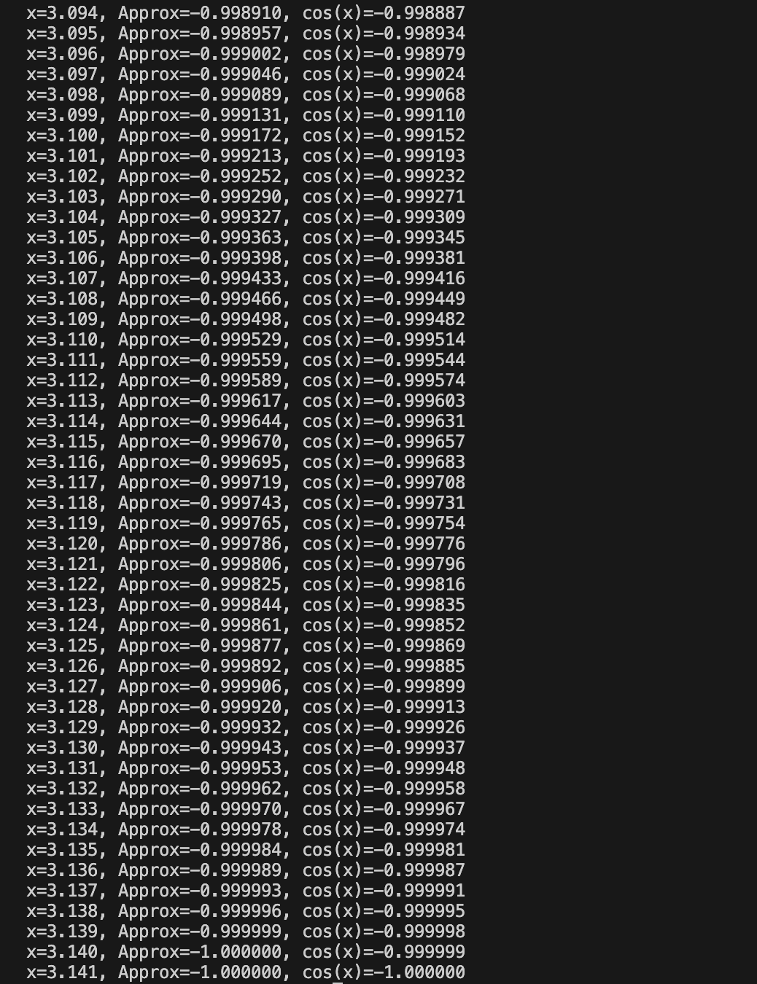

Lab Task 4:

# Lab Task 4
birthdays = {
"Abu Bakr": "03/14/2005",
"Abbas": "01/17/2009",
"Abdul Wali": "12/10/1996"
}

print("Welcome to the birthday dictionary. We know the birthdays of:")
for name in birthdays:
print(name)

person = input("Who's birthday do you want to look up? ")
if person in birthdays:
print(f"{person}'s birthday is {birthdays[person]}.")
else:
print("Sorry, we don't have that birthday.")
Output:

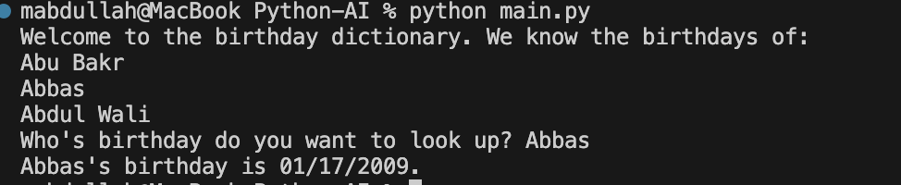

Lab Task 5:

# Lab Task 5
sample_dict = {
"name": "Kelly",
"age": 25,
"salary": 8000,
"city": "New york"
}
keys = ["name", "salary"]

new_dict = {k: sample_dict[k] for k in keys}
print(new_dict)

Output:

